For All Foreign Nationals
By Administrative Lawyers
（Gyoseishoshi）
Ｆｒｅｅ Ｉｍｍｉｇｒａｔｉｏｎ Ｃｏｕｎｓｅｌｉｎｇ
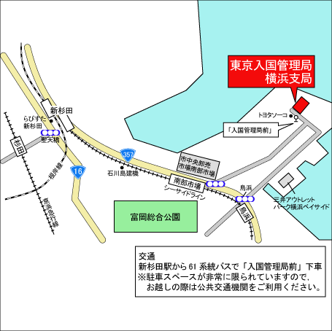
Qualified Administrative Lawyers（Gyoseishoshi）under Application Intermediary System of Immigration Bureau will provide answers to foreigner’s questions of VISA, Immigration Procedures, Naturalization, Nationality, newly revised Immigration Law, etc. Please do not hesitate to consult us.
Time： October 24, 2017 (Tue)
10:00a.m.～4:00p.m.(Desk closes at 3:30p.m.）

Location:Ministry of Justice,
Yokohama District Immigration Office, 2F Hall
Take Route No.61 bus from “Shinsugita-Station”and get off at “Immigration Bureau”

Language Japanese, English, Chinese, Korean

Host ： Japan Federation of Administrative Lawyers’ Associations, and Administrative Lawyers Associations consisting of JFALA Kanto District Council
Support ： The Ministry of Justice, Yokohama District Immigration Office
Kanagawa Administrative Lawyers （Gyoseishoshi） Association
http://www.kana-gyosei.or.jp/

